IP Management – Public IP Pools with ORM stack

Contents
1. Introduction 3
2. Workflow diagram to deploy the stack 3
3. Create stack for IP Management-Public IP Pools 4
4. Plan the Job 6

Introduction

A public IP pool is simply a set of IPv4 CIDR blocks allocated to a tenancy. These CIDR blocks can be all or part of a BYOIP CIDR block. Public IP CIDR blocks assigned to a pool are only available for user’s tenancy. Public IP pools are available as a source for IP allocation when launching a NAT gateway, load balancer, or compute instance. User can add more IP CIDR blocks to a public IP pool at any time. User can also:
- Create a Reserved IP: User can reserve individual IPs from user’s public IP pools. These reserved IP addresses can be attached to user’s resources.
- Direct launch from pool: User can launch resources with an IP directly allocated from a public IP pool without previously creating a reserved IP for that resource.
- Delete CIDR blocks and pools: User can delete the entire public IP pool or certain IP CIDR blocks within the pool, provided none of the IP addresses are currently attached or reserved.

Workflow diagram to deploy the stack

Below diagram shows how the Terraform Artifact are applied in the OCI. While creating a ORM stack, using terraform deliverables Init, Plan and Apply is the flow to provision the resource in the OCI. We can have the deliverables in any of below.

- GitLab/GitHub Repo
- Bitbucket
- Can be in folder/.zip in the local disk
- Object Storage Bucket
- Can be in compartment
- Oracle provided Template



Create stack for IP Management-Public IP Pools

Go to OCI Console Developer Services Resource Manager Stacks select the compartment Create Stack

My Configuration Folder Browse Select the “public_ip_pool” folder that contains the terraform Upload.

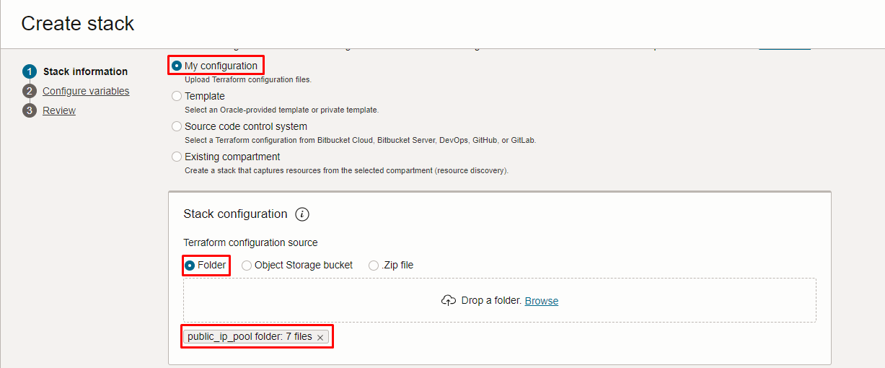
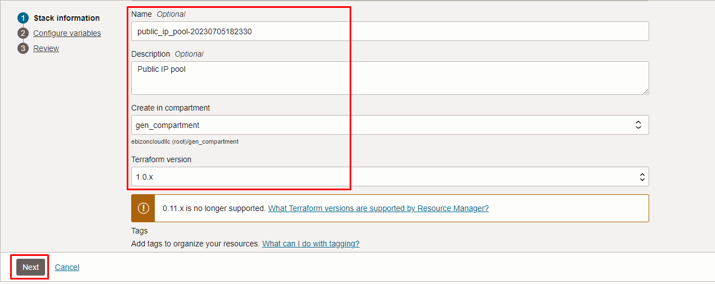

Click “NEXT”

Select the parameters as per the below screen,

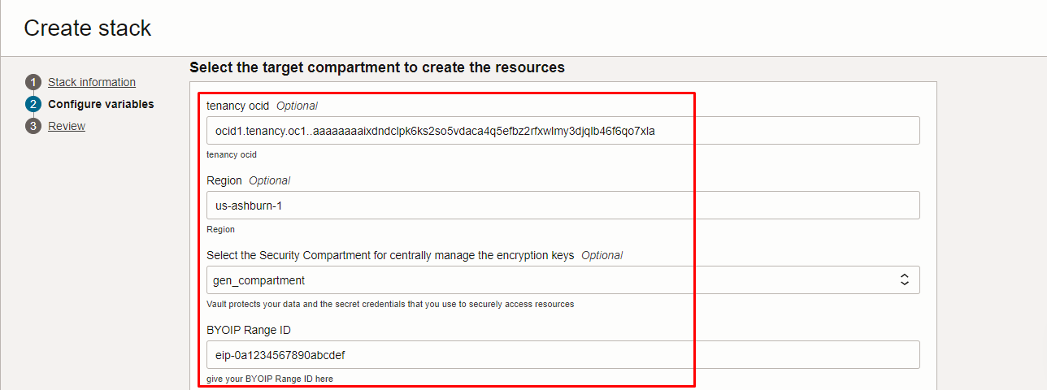
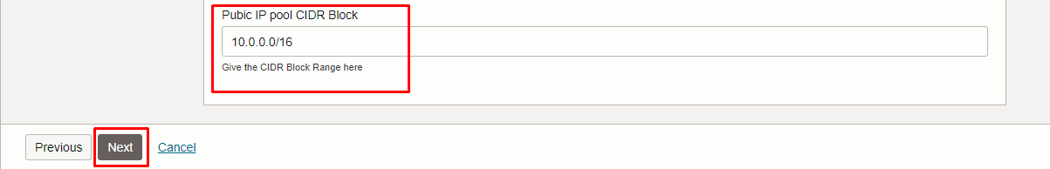

Click “NEXT” Click “CREATE”

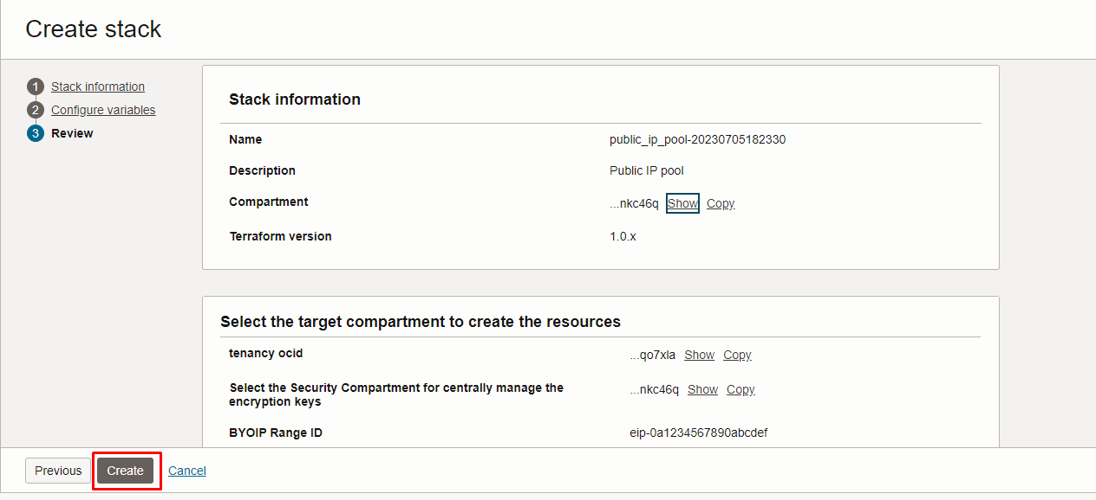

Plan the Job

Click the “Plan”
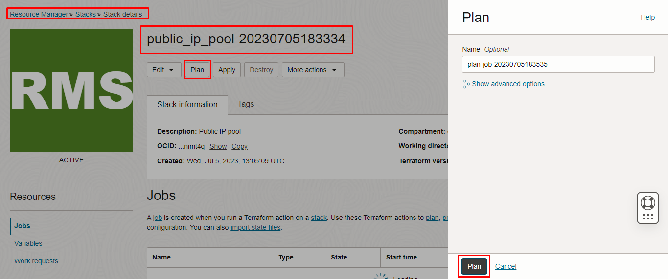
Verify the Plan is successful.
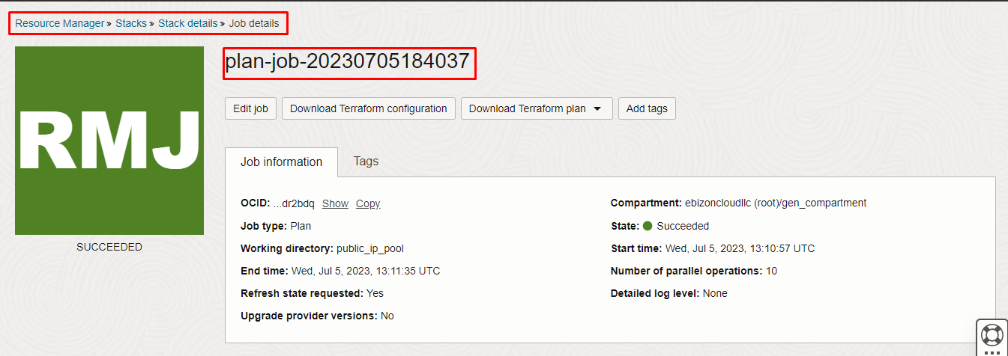
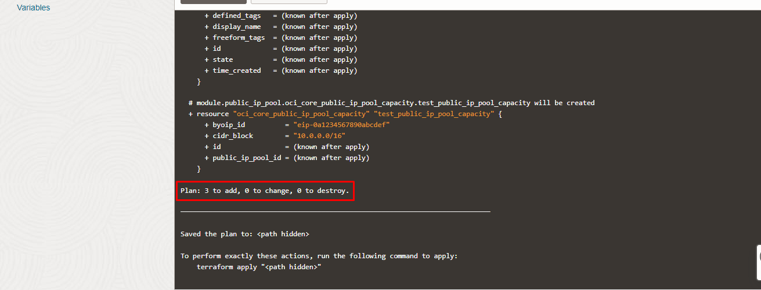

# END #

